Hardware Report / Build Instructions
Raspberry Pi RFID Reader and LED Indicator
CENG 317 Project
Build Instructions
Prepared for project reproduction by Hoang Tran

Contents
1.0 Introduction 2
2.0 Added Functionality 3
2.1 Sensor/Effector Purchase 3
2.2 PCB Design and Soldering 3
2.3 Case Design and Assembly 4
2.4 Firmware Development and Use 4
2.4.1 Raspberry Pi Configuration 4
2.4.2 Python Environment 5
2.4.3 Program Configuration 5
2.4.4 Running and Stopping the Application 5
3.0 Testing and Results 6
Troubleshooting 7
4.0 References 7

1.0 Introduction
This project uses a Raspberry Pi as the Broadcom-based development platform for an RFID identification system. The Raspberry Pi runs Raspberry Pi OS and provides GPIO and I2C interfaces for external hardware. The completed system reads an RFID tag through an I2C reader and provides a visual status indication with an LED.
The target audience is a Computer Engineering Technology student with basic Linux, Raspberry Pi GPIO, Python, and electronic assembly experience. The procedure is organized so that the project can be recreated from hardware assembly through software configuration and functional testing.
The RFID interface used by the completed project is available on Raspberry Pi I2C bus 1 at address 0x15. The status LED is controlled from BCM GPIO 17. Two Python threads allow RFID monitoring and LED control to operate concurrently.

2.0 Added Functionality
The added functionality consists of an RFID reader interface, an LED status indicator, and Python firmware that coordinates both devices. The reader supplies tag data to the Raspberry Pi through I2C. The program reads a 16-byte block from I2C address 0x15 and uses the first six bytes as the tag identifier when non-zero data is present.
When no tag is present, the LED turns on for one second and off for one second. When a new tag is detected, the LED blinks five times using a 0.2-second on/off delay. A removal signal is recognized when the first six bytes returned by the reader are zero. This prevents a tag that remains on the reader from continuously retriggering the detection indication.

2.1 Sensor/Effector Purchase
The following hardware is required. Equivalent parts may be substituted only when their electrical requirements and interfaces are compatible with the project schematic.
Item | Purpose / Requirement
Raspberry Pi | Broadcom-based controller running Raspberry Pi OS; I2C bus 1 and GPIO are required.
RFID reader / interface board | Reads RFID tags and supplies tag data to the Raspberry Pi. The completed project uses I2C address 0x15.
RFID tag/card | Used to verify tag and UID detection.
LED | Provides idle and tag-detection indications.
Current-limiting resistor | Placed in series with the LED according to the project schematic.
PCB / prototype board | Provides the electrical interface between the RFID hardware and Raspberry Pi.
Jumper wires / connectors | Connect power, ground, I2C, and LED signals.
Raspberry Pi power supply | Stable supply appropriate for the Raspberry Pi model used.

Before assembly, identify the RFID board supply, ground, SDA, and SCL connections. The project schematic should be used as the authoritative source for connector pin order and supporting PCB components.

2.2 PCB Design and Soldering
The PCB provides the physical electrical connections required by the RFID reader and Raspberry Pi. Review the schematic before soldering to identify power, ground, I2C SDA, I2C SCL, and LED-related connections. Do not connect the board to a powered Raspberry Pi until continuity and polarity have been checked.
1. Compare the fabricated PCB with the schematic and component placement drawing.
2. Identify connector orientation and the locations of power, ground, SDA, and SCL.
3. Install low-profile components first, followed by connectors and taller components.
4. Solder each joint without bridging adjacent pads.
5. Inspect for solder bridges, cold joints, reversed connectors, and damaged traces.
6. Use a multimeter to confirm that power and ground are not shorted.
7. Verify continuity from the Raspberry Pi interface to the corresponding RFID board signals.
8. Connect the board to the Raspberry Pi only after the electrical inspection is complete.
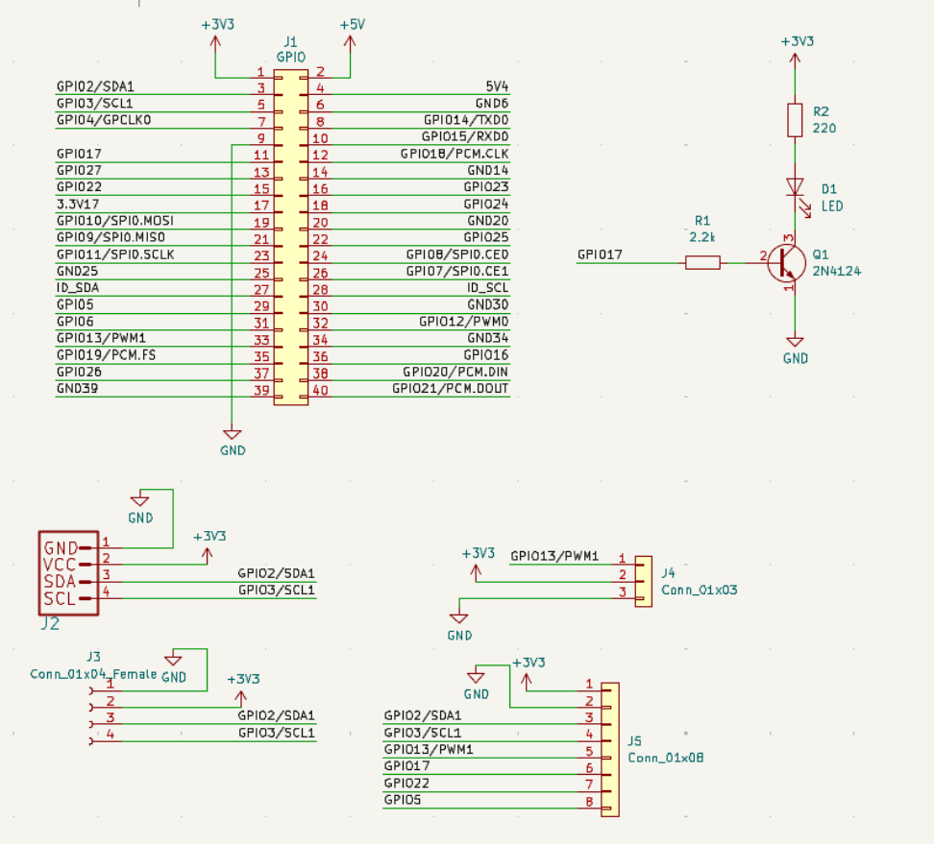
Figure 1. Project schematic
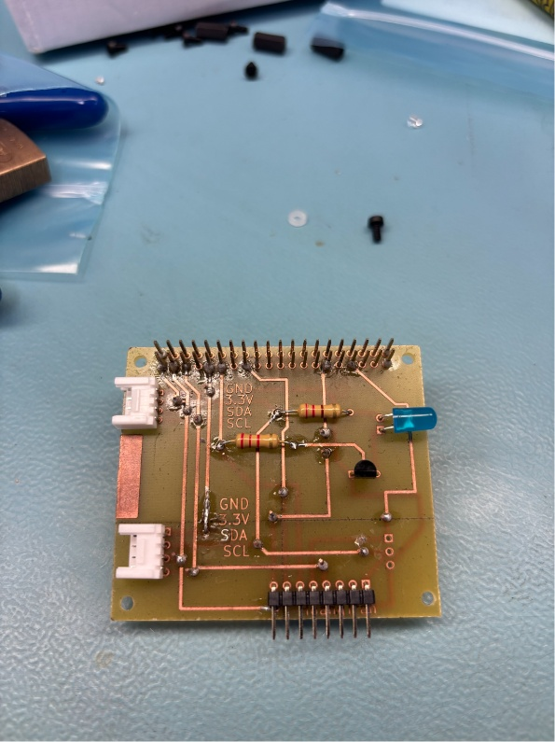
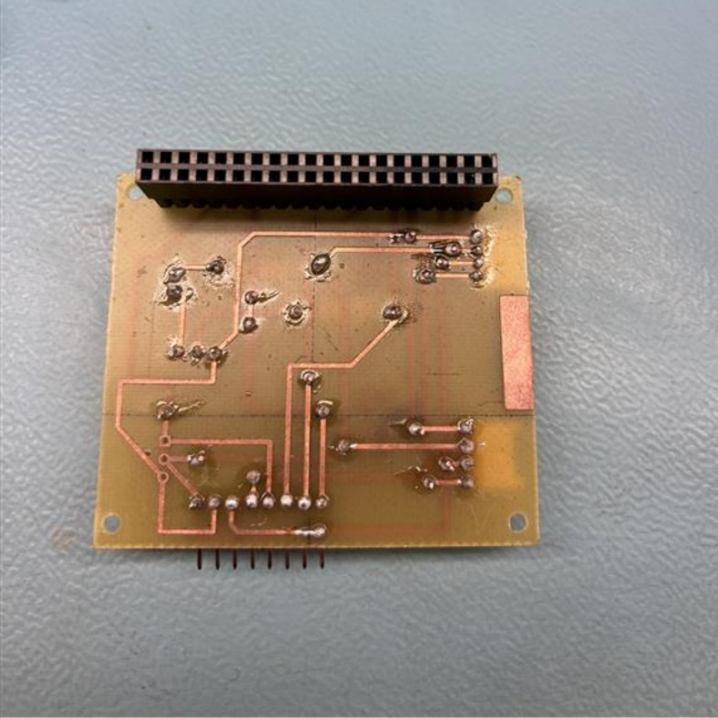
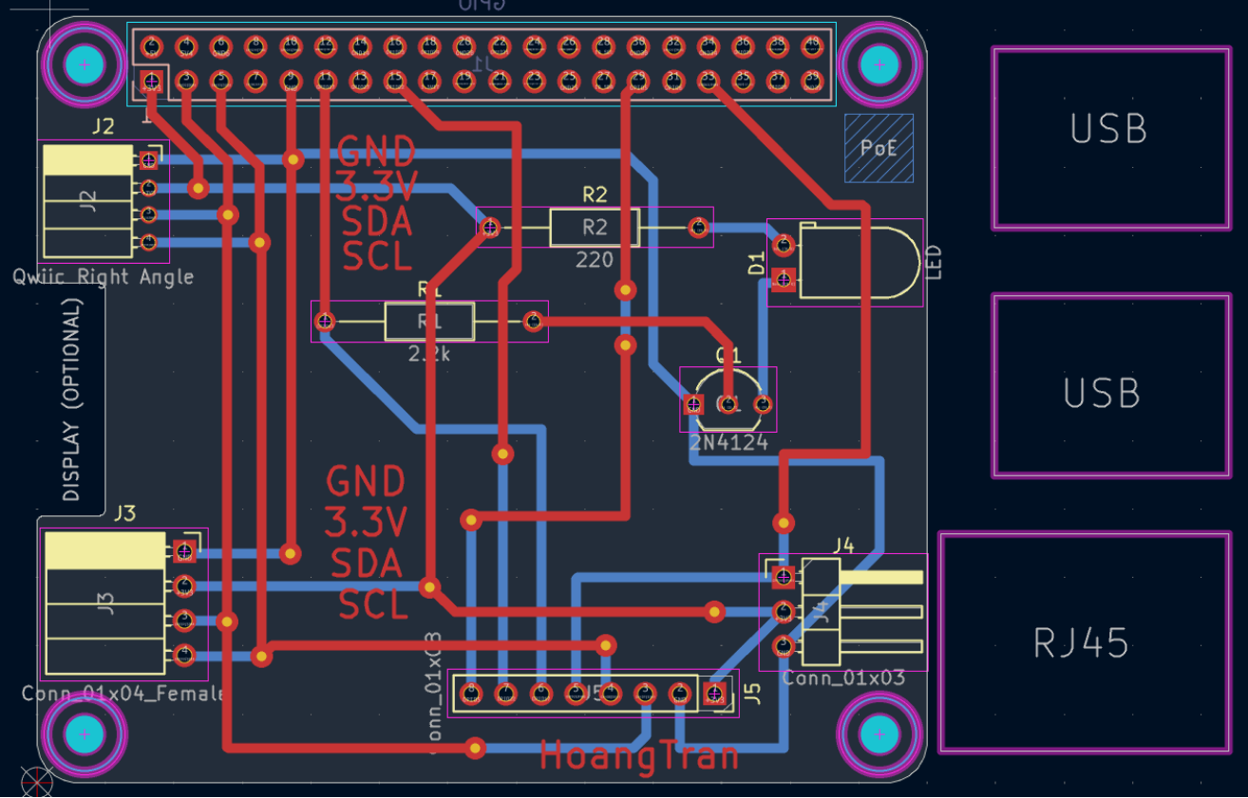Figure 2. PCB layout / KiCad design
Figure 3. Soldered PCB

2.3 Case Design and Assembly
The final assembly should secure the Raspberry Pi, RFID interface board, RFID reader, and LED while leaving the RFID scanning area accessible. The enclosure or mounting arrangement should prevent exposed conductive surfaces from contacting the Raspberry Pi or PCB.
1. Mount the Raspberry Pi so that power and required ports remain accessible.
2. Mount the PCB so that it cannot move or contact the underside of the Raspberry Pi.
3. Position the RFID reader so that a tag can be placed close to the active reading area.
4. Position the LED where it is clearly visible.
5. Route wires so that SDA, SCL, power, ground, and GPIO connections cannot be pulled loose.
6. Recheck all connections against the schematic before applying power.
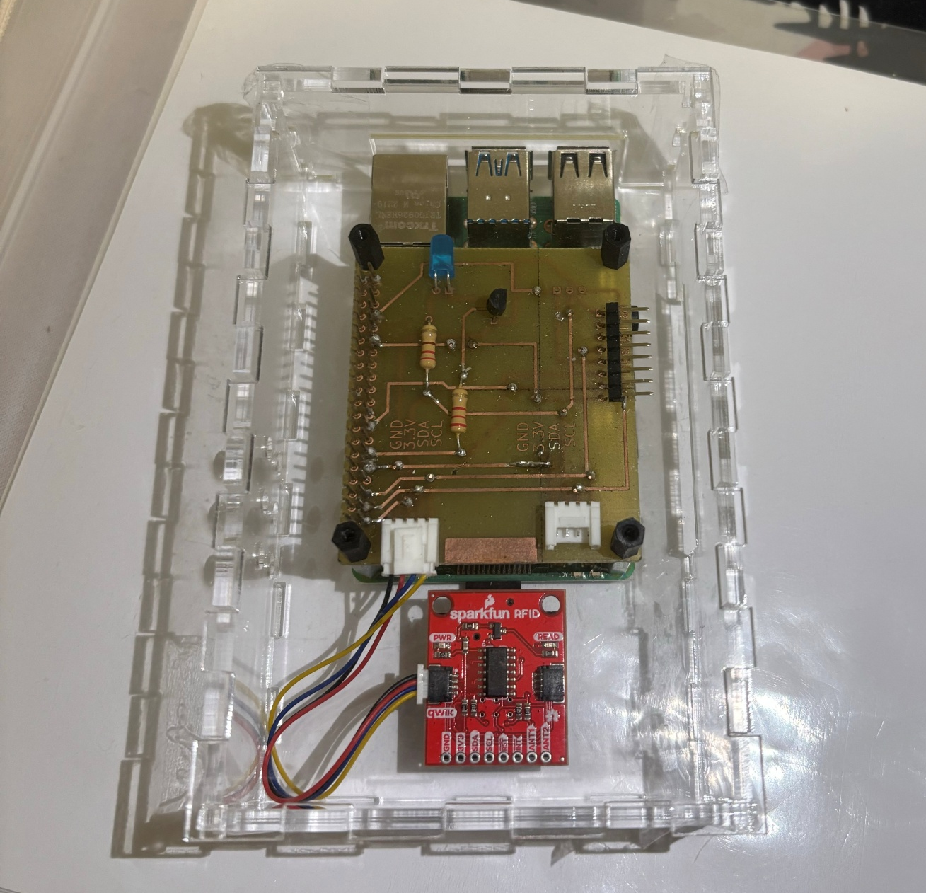
Figure 4. Completed hardware assembly

2.4 Firmware Development and Use

2.4.1 Raspberry Pi Configuration
Open a terminal and update package information:
sudo apt update
Enable I2C using the Raspberry Pi configuration utility:
sudo raspi-config
Select Interface Options, select I2C, enable the interface, and reboot:
sudo reboot
Confirm that I2C bus 1 is available:
ls /dev/i2c*
The expected device is /dev/i2c-1. Install the I2C diagnostic tools:
sudo apt install -y i2c-tools
Scan bus 1:
sudo i2cdetect -y 1
The RFID interface should appear at address 0x15. If 0x15 does not appear, remove power and check SDA, SCL, power, ground, connector orientation, and solder joints.
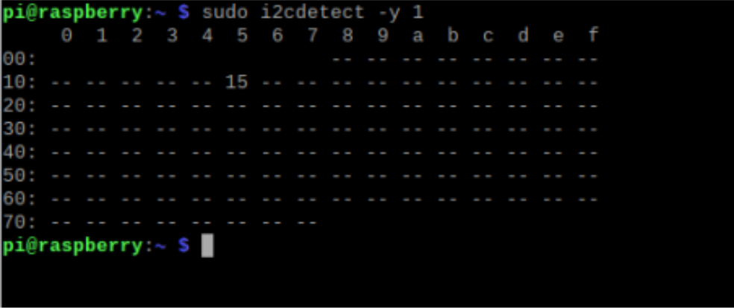Figure 5. i2cdetect result showing address 0x15

2.4.2 Python Environment
Confirm that Python 3 is installed:
python3 --version
Install the SMBus Python package:
python3 -m pip install smbus2
The program also imports RPi.GPIO for GPIO control. If this module is unavailable, install the appropriate RPi.GPIO package for the Raspberry Pi OS installation before continuing.

2.4.3 Program Configuration
Create the program file:
nano rfid_led.py
The hardware-specific constants are:
I2C_BUS = 1
RFID_ADDR = 0x15
LED_PIN = 17
The LED timing parameters are:
IDLE_DELAY = 1.0
TAG_BLINK_COUNT = 5
TAG_BLINK_DELAY = 0.2
The RFID thread repeatedly reads 16 bytes from register 0x00 at address 0x15. The first six bytes are checked. Six zero bytes indicate removal. Non-zero data indicates a tag; when no tag was previously present, the first six bytes are recorded as the UID and a new-tag event is generated.
The LED thread responds to the shared tag state. A new tag produces five fast blinks. No tag produces the one-second idle blink. A tag that remains on the reader leaves the LED off after the initial detection sequence. A threading lock protects the shared tag_present and new_tag variables.
The RFID loop catches temporary OSError exceptions so that a single I2C communication error does not immediately terminate the application. Continuous communication errors require hardware inspection.

2.4.4 Running and Stopping the Application
Run the program from the directory containing the Python file:
python3 rfid_led.py
At startup, the terminal should indicate that both threads have started:
RFID thread started
LED thread started
When a tag is detected, the terminal should display:
Tag detected!
UID: [ ... ]
Press Ctrl+C to stop the application. The program stops both threads, turns the LED off, releases GPIO resources with GPIO.cleanup(), closes the SMBus connection, and prints Cleanup complete.

3.0 Testing and Results
Testing should be completed after hardware assembly, Raspberry Pi configuration, and firmware installation. Screenshots and photographs should be inserted as evidence for the completed tests.
Test | Procedure | Expected Result
Power/visual inspection | Inspect wiring and PCB before power is applied. | No shorts, reversed connectors, loose wires, or visible solder bridges.
I2C bus | Run ls /dev/i2c*. | /dev/i2c-1 is available.
RFID address | Run sudo i2cdetect -y 1. | RFID interface is detected at 0x15.
Idle indication | Run the program with no tag present. | LED turns on for 1 s and off for 1 s repeatedly.
Tag detection | Place a valid RFID tag on the reader. | Terminal displays Tag detected! and a UID.
Detection indication | Observe LED after a new tag is detected. | LED blinks five times using 0.2 s on/off timing.
Tag held in place | Keep the same tag on the reader. | Detection sequence is not continuously retriggered.
Tag removal | Remove the RFID tag. | Removal is recognized and idle blinking resumes.
Second detection | Remove the tag, wait for idle, then present a tag again. | A new detection event occurs and the LED blinks five times.
Shutdown | Press Ctrl+C. | Threads stop, LED turns off, GPIO is cleaned up, I2C closes, and Cleanup complete appears.

Troubleshooting
Problem | Checks / Corrective Action
0x15 is not shown by i2cdetect | Check I2C enablement, SDA/SCL wiring, board power, ground, connector orientation, solder joints, and continuity.
Python import error | Confirm Python 3 and required packages are installed in the Raspberry Pi environment.
LED does not blink | Check BCM numbering, GPIO 17 wiring, LED polarity, resistor connection, and common ground.
Tag is not detected | Confirm address 0x15, tag compatibility, reader position, and returned I2C data.
Repeated I2C errors | Power down and inspect wiring, supply stability, soldering, and I2C connections before retesting.

4.0 References
1. OACETT. Technology Report Guidelines. Revised September 2022. Reference identified in the supplied Hardware Report / Build Instructions template.
2. Raspberry Pi documentation. Raspberry Pi OS, I2C, and GPIO configuration documentation applicable to the Raspberry Pi model used.
3. Project schematic, PCB design files, and RFID interface documentation used for the completed hardware.

